**Session6 - Assignment 3**

**1. Read input and find the total number of rows**

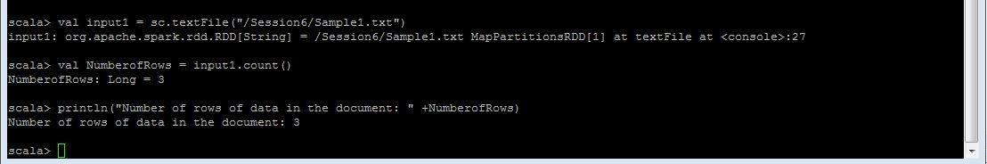

**2. Total number of words in a file**

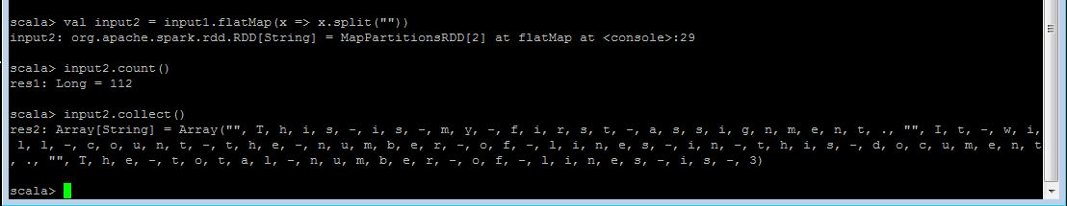

**3. Find the total number of words with “-“ separator**

